**Types of Machine Learning**

**Introduction to Machine Learning**

Machine Learning (ML) is a subfield of Artificial Intelligence (AI) that enables systems to automatically learn and improve from experience without being explicitly programmed. Instead of writing detailed instructions for every task, ML systems learn patterns from data and use them to make predictions or decisions.

In today’s world, Machine Learning is everywhere—when Netflix recommends movies, when Gmail filters spam, when banks detect fraud, or when cars drive themselves.

**Why Machine Learning Matters**

* **Data-driven world**: With billions of data points generated daily, ML helps extract valuable insights.
* **Automation**: ML reduces human effort in repetitive and complex tasks.
* **Prediction power**: It enables forecasting trends, risks, and behaviors.

**Difference Between AI, ML, and Deep Learning**

* **AI (Artificial Intelligence)**: The broad concept of machines mimicking human intelligence.
* **Machine Learning**: A subset of AI focused on learning from data.
* **Deep Learning**: A subset of ML using neural networks with many layers.

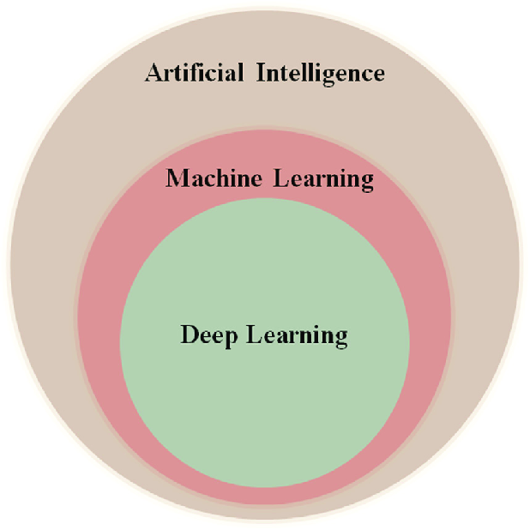

**Types of Machine Learning**

Machine Learning is broadly classified into three types:

1. **Supervised Learning**
2. **Unsupervised Learning**
3. **Reinforcement Learning**

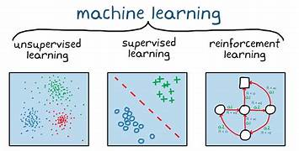

Each type has unique methods, goals, and applications. Let’s explore them in detail.

**Supervised Learning**

Supervised Learning is the most common form of Machine Learning. In this method, the algorithm is trained on a **labeled dataset**, meaning that each training example has both input data and the correct output (label).

**How It Works**

1. Provide the model with input–output pairs.
2. The model learns a mapping function between input features and the correct output.
3. Once trained, the model can predict outcomes for unseen data.

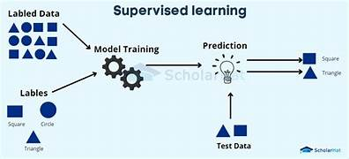

**Types of Supervised Learning**

* **Regression**: Predicts continuous values.
  + Example: Predicting house prices based on size, location, and amenities.
  + Algorithm examples: Linear Regression, Ridge Regression.
* **Classification**: Predicts discrete categories.
  + Example: Determining whether an email is *Spam* or *Not Spam*.
  + Algorithm examples: Logistic Regression, Decision Trees, Random Forest, Support Vector Machines.

**Real-World Applications**

* **Healthcare**: Predicting whether a tumor is malignant or benign.
* **Finance**: Credit scoring and fraud detection.
* **Retail**: Predicting customer churn and sales forecasting.
* **Technology**: Speech recognition and sentiment analysis.

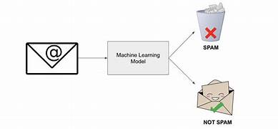

**Unsupervised Learning**

Unlike supervised learning, **Unsupervised Learning** deals with **unlabeled data**. The system tries to learn the underlying structure or patterns in the dataset without predefined outcomes.

**How It Works**

1. The algorithm receives raw input data.
2. It looks for similarities, patterns, or groupings.
3. The insights can be used for segmentation, dimensionality reduction, or anomaly detection.

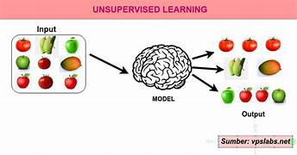

**Types of Unsupervised Learning**

* **Clustering**: Grouping data into clusters based on similarity.
  + Example: Grouping customers by shopping behavior.
  + Algorithms: K-Means, Hierarchical Clustering, DBSCAN.
* **Dimensionality Reduction**: Simplifying datasets by reducing the number of features while preserving patterns.
  + Example: Reducing image pixel dimensions before processing.
  + Algorithms: PCA (Principal Component Analysis), t-SNE.

**Real-World Applications**

* **Marketing**: Customer segmentation for targeted advertising.
* **Finance**: Detecting unusual credit card transactions (anomaly detection).
* **Biology**: Grouping genes with similar expression patterns.
* **E-commerce**: Product recommendations (“People who bought this also bought…”).

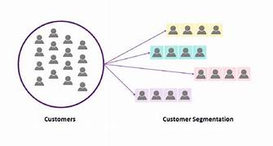

**Reinforcement Learning**

Reinforcement Learning (RL) is inspired by how humans and animals learn from interaction with their environment. In this type, an **agent** learns to make decisions by performing actions and receiving feedback in the form of **rewards or penalties**.

**How It Works**

1. The agent interacts with the environment.
2. Each action leads to a new state and provides a reward (positive or negative).
3. Over time, the agent learns a policy (strategy) to maximize cumulative reward.

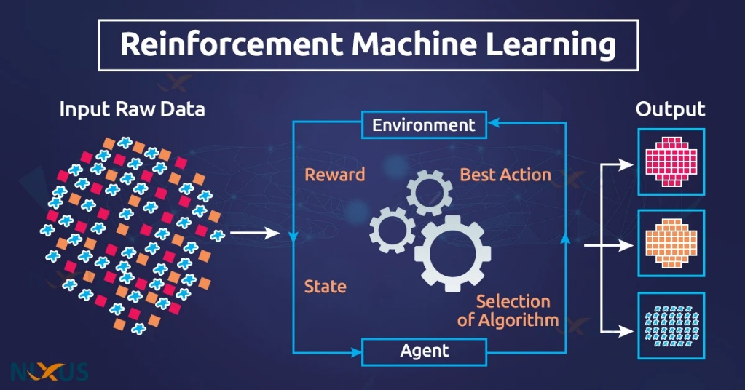

**Key Concepts**

* **Agent**: Learner or decision-maker.
* **Environment**: The system the agent interacts with.
* **Reward**: Feedback signal to guide learning.
* **Policy**: The strategy used by the agent to act.
* **Exploration vs. Exploitation**: Balancing trying new actions vs. using known strategies.

**Real-World Applications**

* **Gaming**: AlphaGo defeating human champions in Go.
* **Autonomous Vehicles**: Learning to drive safely in traffic.
* **Robotics**: Teaching robots to walk or grasp objects.
* **Finance**: Automated trading systems.

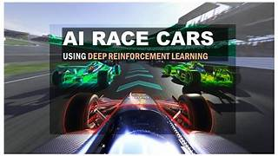

**Real-World Impact of Machine Learning**

* **Healthcare**: ML-powered diagnosis improves patient care.
* **Finance**: Fraud detection protects billions in assets.
* **E-commerce**: Personalization boosts customer experience.
* **Transportation**: Autonomous driving is reshaping mobility

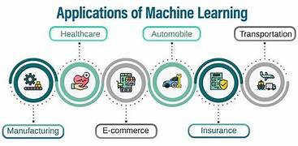

**Conclusion**

Machine Learning is not a single technology but a collection of techniques adapted to different problem types.

* **Supervised Learning** is powerful when labeled data is available and predictions are needed.
* **Unsupervised Learning** helps uncover hidden patterns where labels are absent.
* **Reinforcement Learning** shines in sequential decision-making tasks involving interaction and rewards.

Together, these three types form the foundation of Machine Learning and drive innovations across industries. As data continues to grow and computing power increases, the future of ML promises even more breakthroughs—from smarter healthcare to autonomous robots and beyond.

